**BRANCH LOCATIONS**

**TO START  
1.) Menu  
2.) Maintenance  
3.) Branch location**

1 1*1*

Branch Location

Maintenance

Menu

33 1*1*

2 1*1*

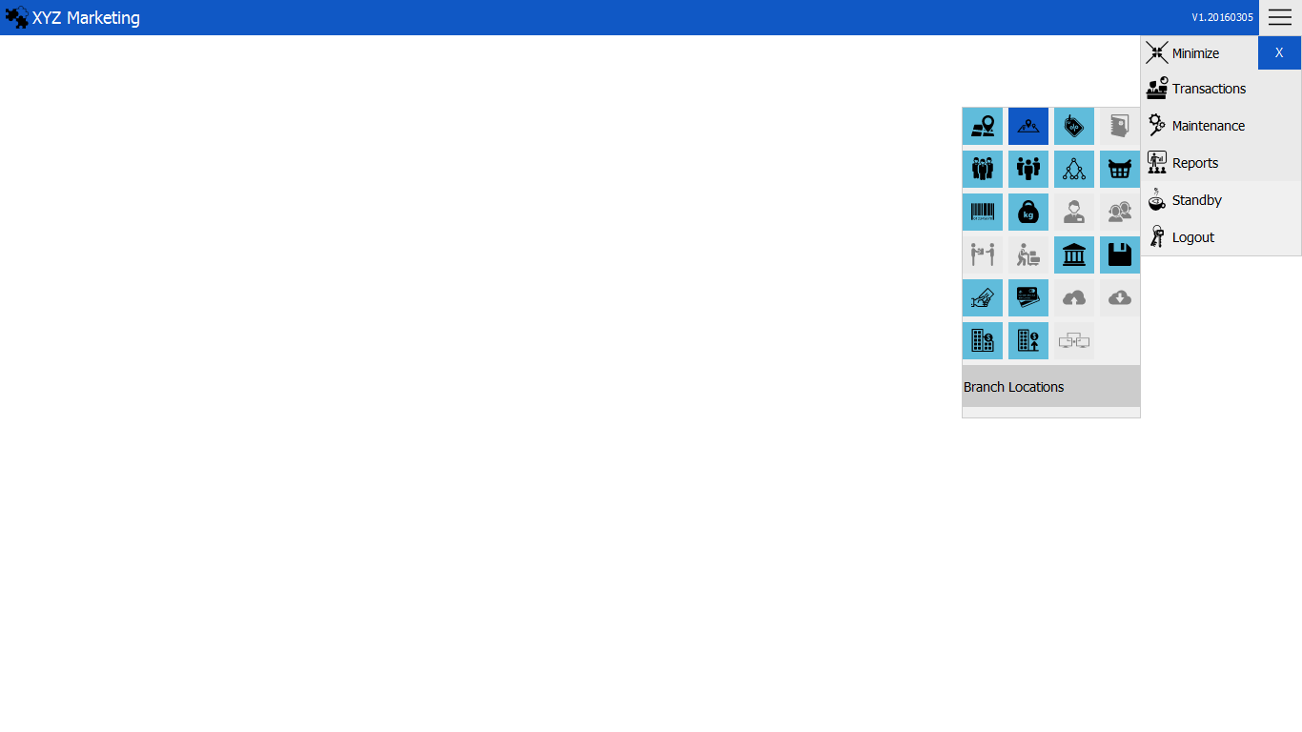

**ADD NEW BRANCH LOCATION  
1.) Select branch   
2.) Input the new location  
3.) Add**

Add

Select branch

1 1*1*

3 1*1*

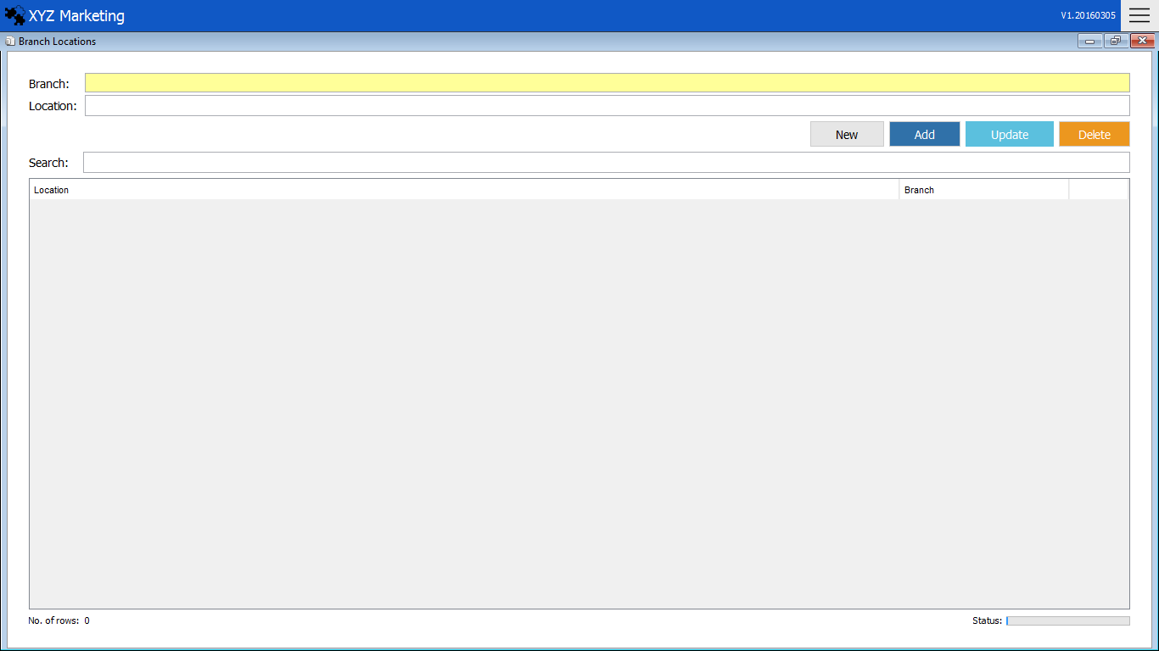

Input location

2 1*1*

Search box

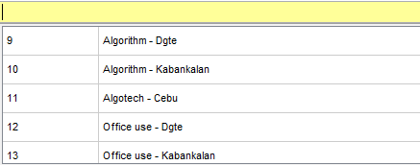 **1.) Select branch**

Choose the branch displayed upon opening the input box.

**2.) Input the new location**

Input the new branch location to be added.

**3.) Add,Update & Delete**

**3.1) Add**

After filling up the details, just click the add button to finish.

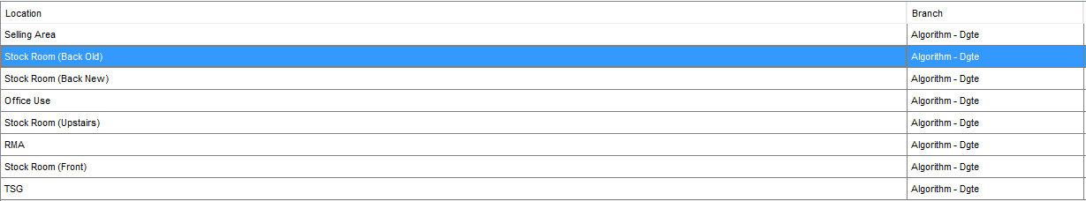**3.2) Update**

Click the location in the list that you want to update and change.



Click the update button to finish.

**3.3)Delete**



Click the delete button to finish.

Click the location in the list that wanted to delete.